BY THE SUNDAY TIMES BESTSELLING AUTHOR

CAROLINE TAGGART

MISADVENTURES IN THE ENGLISH LANGUAGE

MICHAEL O’MARA BOOKS / 3rd November 2016 / £9.99 Hardback

Lifelong word enthusiast Caroline Taggart takes an entertaining look at some of the more confusing aspects of modern English and tries to assess what matters and what really doesn’t.

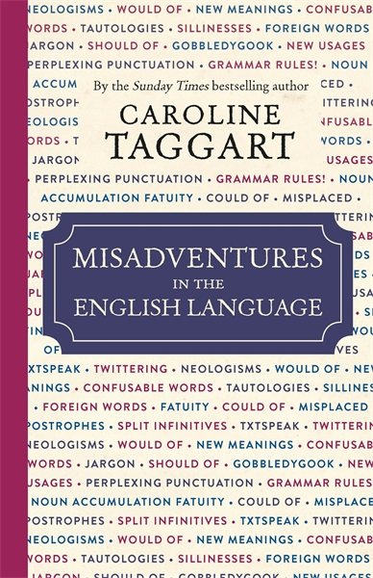
Language is a complex and ever-changing creature, so how can we know what is right or wrong at any given time? Misadventures in the English Language shows how a comma can make all the difference, why tautologies are simply annoying; how corporate speak can actually mean nothing at all; and why naughty, awful, sophisticated and virtue are all words that have evolved to mean something completely different, this book covers all the aspects of the English language that could leave you with cause for concern.
It also considers where we are now, appraising (and often praising) the invention of new words from kidult to piscetarian, including internet-led abbreviations such as JK and IMHO. By turns an explanation of the rules, a rant against gobbledygook and other modern horrors, this book will aid you in avoiding embarrassing clichés and jargon, and help you put your words in the right places, finally enabling you to revel in the richness of the English language.
Praise for New Words for Old:
'Pleasantly diverting' Guardian
'Fascinating ... perfect for anyone obsessed by wordplay' Yours magazine

ABOUT THE AUTHOR: Caroline Taggart worked in publishing as an editor of popular non-fiction for thirty years before being asked by Michael O'Mara Books to write I Used to Know That, which became a Sunday Times bestseller. Following that she co-wrote My Grammar and I (or should that be 'me'?), Answers to Rhetorical Questions, A Classical Education, An Apple a Day and Pushing the Envelope. She has appeared frequently on television and on national and regional radio, talking about language, grammar and Pythagoras's theorem. New Words for Old and Misadventures in the English Language are her latest books for Michael O'Mara.
Her website is carolinetaggart.co.uk and you can follow her on Twitter @citaggart.

For more information please contact
Katherine Stroud PR COLLECTIVE
07780112964 / kstroudpr@gmail.com
Or visit www.mombooks.com

