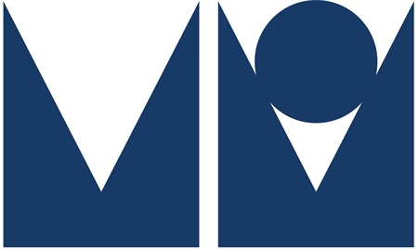

Michael O’Mara Books Limited
16 Lion Yard, Tremadoc Road
London SW4 7NQ

Contact: Saskia Angenent
Direct Line: 0207 819 5911
Email: Saskia.angenent@mombooks.com

Published 25th January 2018
Hardback / Ebook £20.00

Pandemic 1918: The Story of the Deadliest Influenza in History

Catharine Arnold

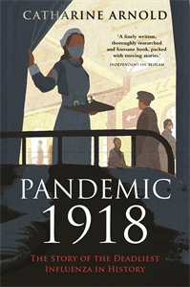
At the end of World War I, Spanish Flu suddenly overwhelmed the world, killing 100 million people worldwide. For context, the First World War killed 18 million and the Second World War killed 60 million.

Published on the centenary of the deadliest human disaster in recorded history, discover the human story behind the pandemic.
German soldiers termed it Blitzkatarrh, British soldiers called it Flanders Grippe, but globally the pandemic gained the notorious title of ‘Spanish Flu’.
Nowhere escaped this common enemy: 250,000 people died in Britain, 750,000 in the US, while European deaths reached over two million. Yet at the time, news of the danger was suppressed for fear of impacting wartime morale. Even today these figures shock, as the war still hides this terrifying menace in its shadow.
In this expertly researched account, Catharine Arnold delves behind the numbers to discover the human stories of those who suffered and fought it – in the hospitals and laboratories, from Parliament to schools.
Tracing the course of the disease, from its origins to progress across the globe, previously unpublished records, memoirs and diaries uncover the human story of 1918. From British Prime Minister David Lloyd George, US President Woodrow Wilson, writers Robert Graves and Vera Brittain, to doughboys in the US, gold miners in South Africa and schoolgirls in the UK, Arnold marks the centenary with a moving and unique history, filled with eyewitness accounts.
ABOUT THE AUTHOR
Catharine Arnold is a popular TV presenter, academic and author of the much-acclaimed London quartet, a series about the dark side of the capital, consisting of Necropolis: London and its Dead, Bedlam: London and its Mad, City of Sin: London and its Vices and Underworld London: Crime and Punishment in the Capital. Her first novel, Lost Time, won a Betty Trask Award. Catharine read English at the University of Cambridge and holds a further degree in Psychology.
Catharine Arnold is available for interview and to write pieces

