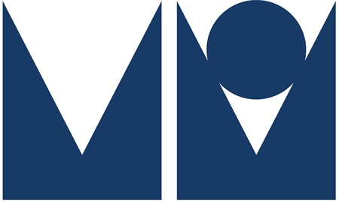

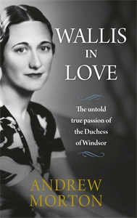
Wallis in Love: The untold true passion of the Duchess of Windsor

Andrew Morton

Published by Michael O’Mara Books
Under embargo until 14th February 2018
Hardback, £20

A vivid, fresh and explosive new portrait of Wallis Simpson, the Duchess of Windsor, by the world’s best-known royal biographer, Andrew Morton
It was described as the most poignant royal love story of the century - a man and a woman equally united by love that divided a church, a parliament, a country and an empire.
The decision by King Edward Vlll to abdicate his throne for the sake of the woman he loved, twice-married American Wallis Simpson, shocked and stunned the world. But all was not as it seemed.
Drawing on never-before-seen or heard interviews, secret letters and diaries, Morton reveals the men Wallis truly loved, the men who broke her heart – and the hearts she broke in turn. For the first time, it exposes:
- The truly astonishing offer she made days before her wedding to the ex-King, the Duke of Windsor
- How the King’s abdication soured their marriage, with their ensuing lives together being an elaborate charade
- Why the ghost writer hired to pen her memoirs left the job
- What really happened the night her husband died
Wallis in Love is a gripping and enticing portrait that totally transforms our perception of Wallis Simpson.
ABOUT THE AUTHOR
Andrew Morton is one of the world's best-known biographers and a leading authority on modern celebrity and royalty. His ground-breaking 1992 biography Diana: Her True Story revealed the secret world of the Princess of Wales. Written with her full, though then secret, cooperation, the book changed the way the world looked at the British royal family. Since, he has gone on to write No. 1 Sunday Times and New York Times bestsellers on Monica Lewinsky, Madonna, David and Victoria Beckham, Tom Cruise, Angelina Jolie, and, most recently, 17 Carnations: The Windsors, The Nazis and The Cover-Up. The winner of numerous awards, he divides his time between London and Los Angeles.

Andrew Morton is available for interview and to write pieces
Contact: Saskia Angenent / Tel: 0207 819 5911 / email: Saskia.angenent@mombooks.com

